Documentation Project 2: BrewBuddy Pro
1. Running Instructions
Please follow these steps to successfully run the program:
- Unpack the .zip file: Ensure all files (including the Python script and any .txt or .csv files) are located in the exact same directory.
- Fill in the Google Form: Have participants sign up using this link:
https://docs.google.com/forms/d/e/1FAIpQLSd6CeVgLXvRE5YGlkfYEkanezgUMk_-0mmGZOGv39igk2e7Lg/viewform?usp=dialog
- Navigate to the linked Google Sheets and download the data as a .csv file:
https://docs.google.com/spreadsheets/d/1PpeRo5NwWtCWgkyHn9dRoUrztqWxIX0mFlPERe4WtIU/edit?usp=sharing
- Move the downloaded .csv file into the same directory as the Python script. (Tip: Remember to clear the Google Sheet responses after running the script to ensure a clean slate for the next round!)
- Execute the Python script.
Troubleshooting / Error Handling:
If the script cannot automatically locate the .csv file, a built-in guide will appear in the terminal. The program will print the following instructions to guide the user:
CSV file not found.
Follow these steps:
1. Fill in the Google Form
2. Download the responses as CSV
3. Place the CSV file in the same folder as this script
Press Enter when ready...
Note: The script is designed to automatically recognize common default filenames from Google Sheets. As a backup, it will also prompt the user to manually enter the filename in the terminal if the automated search fails.

2. Project Status
All basic project requirements are completed (100%). This includes dynamic CSV reading, configurable group sizes/rounds, residual group handling, random matching, conversation starters, and output formatting.
Beyond the basic requirements, we also implemented the following features to enhance the program:
- We created an option to generate multiple rounds of matches. This way it is easier to plan ahead if you’re reusing the same list of people.
- We integrated a history-tracking system (saving and reading from an all_pairs.csv file). Our code checks past iterations to ensure that the exact same groups are not matched together again in subsequent rounds, which makes the lottery much more effective over time.
- Our code features robust error handling. It automatically searches for common Google Forms CSV filenames. If it fails, it provides an menu to guide the user, alongside input validation for group sizes and round numbers to prevent the program from breaking.

3. Group Members & Task Division
Members: Daan, Jeroen, and Omar.
Note: All listed members participated, no members dropped out. We are not INFOMCTH students.
Task Division:
We kept track of our specific tasks using a GitHub project board (see the attached screenshot of our To-Do list) and a Changelog. You can find the exact breakdown of who wrote which part of the code in the Changelog at the top of our Python script. Broadly speaking:
- Daan: CSV imports, merging code, and input error handling.
- Jeroen: In-program instructions, residual group logic, and documentation.
- Omar: Core random matching algorithm and data logic.
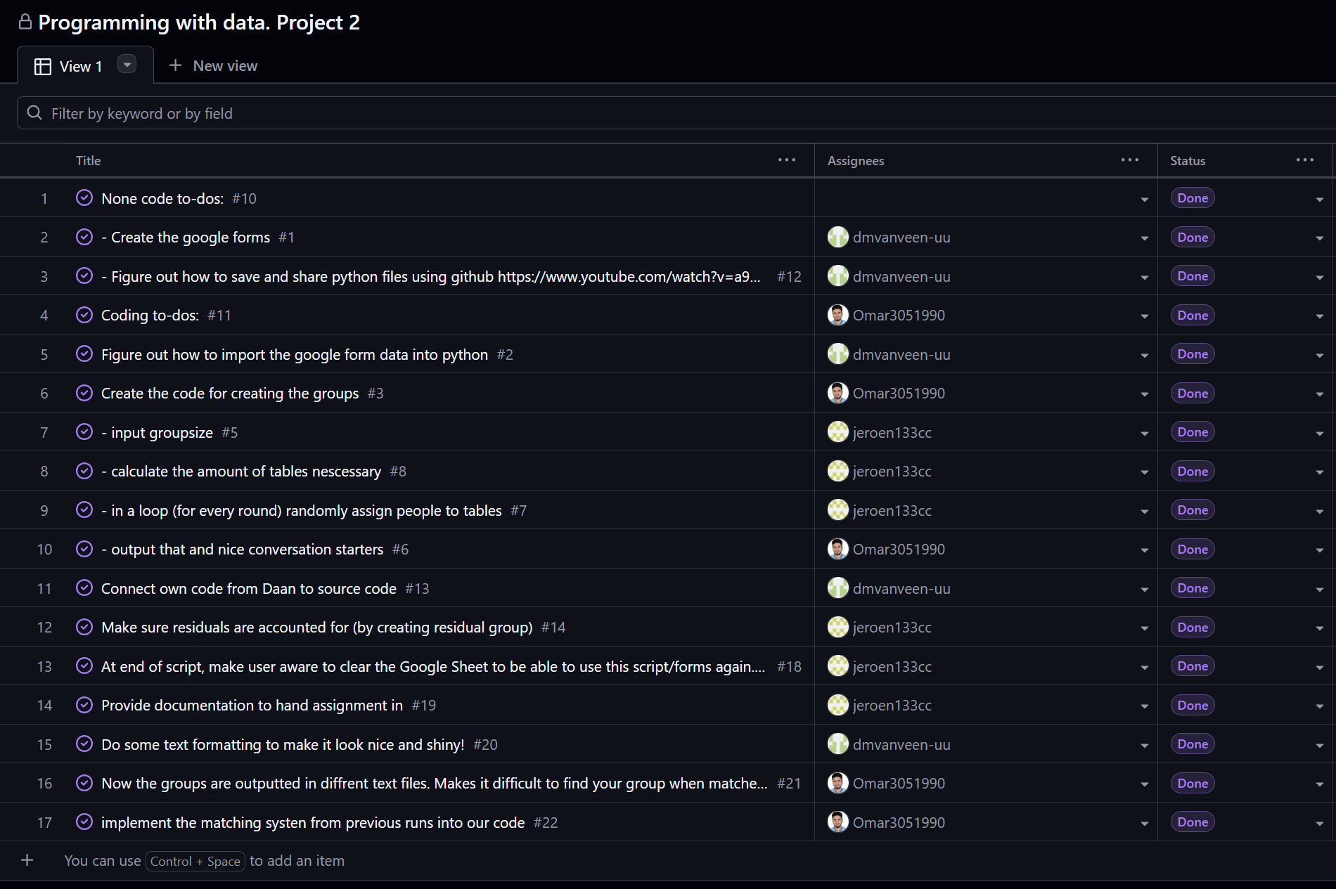

4. Git / GitHub & Workflow
Because we are not INFOMCTH students, using Git/GitHub was not strictly mandatory for us, but we made a serious effort to implement it.
- Public Repository: https://github.com/dmvanveen-uu/Daan-repository/tree/main
- Project Board: https://github.com/users/dmvanveen-uu/projects/2
(Note: The repository is currently public for grading purposes but will be made private again afterward.)
Workflow Reflection:
We worked with separate versions that we uploaded manually via commits. To maintain a clear overview, we kept a changelog in the Python script and utilized the GitHub Projects board to track our tasks. This ensured it was always clear who did what and who to ask if we didn't understand a piece of code. We found this overview very helpful. For future projects, we absolutely want to carry this forward, but integrate it using the official Git workflow (working with proper branches and merges directly).

5. Use of Generative AI
Our use of Generative AI in this project was minimal and strictly facilitative. We used GenAI for three things:
- GitHub Crash Course: We asked AI for a quick crash course on Git/GitHub. While the explanation was good, we concluded that (given the time constraints and our reliance on WhatsApp for remote communication) it would cause too much friction to fully implement standard branching for this specific project.
- Feature brainstorm: We asked AI to think of some features which would help this project to a higher level. We discussed the output in a online meeting. We dediced to do the ‘multiple rounds’ implementation and check whether the API connections for mailing and pulling the Google Forms is within our capabilities.
- API Feasibility Check: We briefly used AI to research integrating a Google Forms API as an extra feature. We concluded that we did not feel comfortable enough with this yet. Getting it to work would have required having AI write significant portions of the code. Because this goes directly against the rules of the assignment, we decided to drop this feature entirely.

